**High Bids Price By City – Module 4**

**MapReduce**

* Data processing layer in Hadoop.
* Processing structured & Unstructured Data in Hadoop.

**Pros**

* Best Performance

**Cons**

* Hard to Extend
* Lack of management tools
* Not suitable for real time processing
* very small community

**Input Directory**

Input directory contains input files that will be processed by MapReduce to calculate amount of high-bid-priced **(more than 250)** impression events by city.

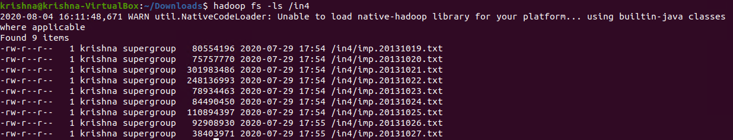

In the above screenshot, we can see an input directory contains 9 input files:

1. imp.20131019.txt
2. imp.20131020.txt
3. imp.20131021.txt
4. imp.20131022.txt
5. imp.20131023.txt
6. imp.20131024.txt
7. imp.20131025.txt

**imp.20131019.txt**

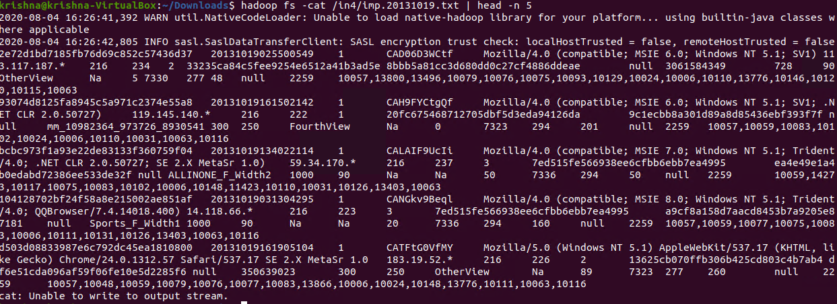

In the above screenshot, we can see the content of the imp.20131019.txt input file.

**Output Directory**

Output directory will be automatically created contains output files.

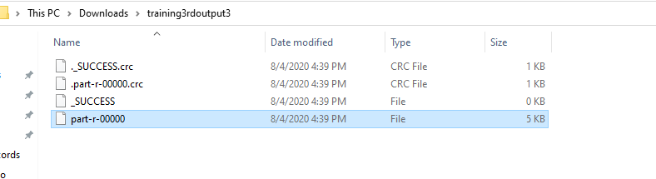

**Read output file Content:**

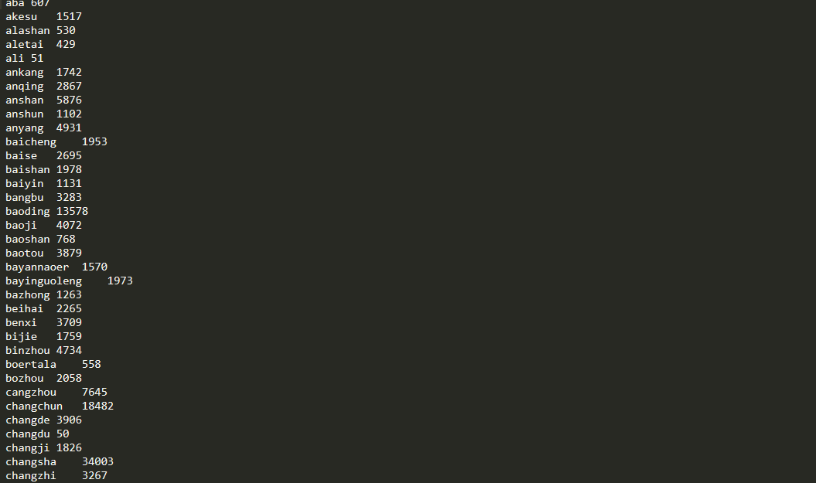

In the above screenshot, we can see the output contains key – represent the name of the city & value – maximum impressions.

**Test Cases:**

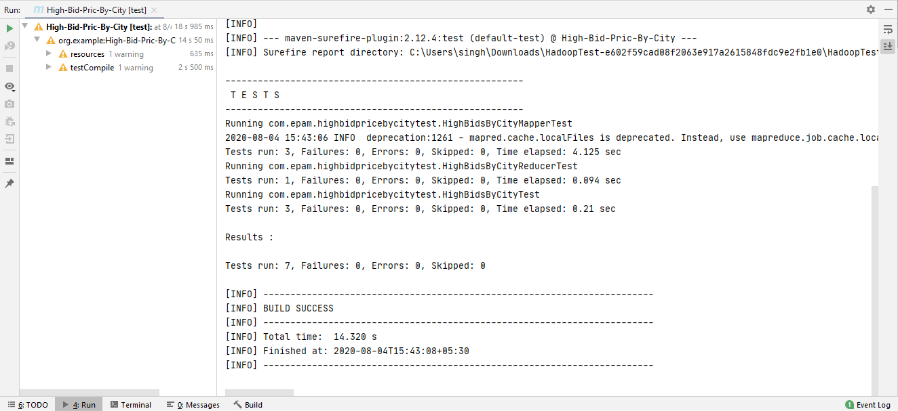

In the above screenshot, we can see that all 7 test cases have passed.